LAB 2 EXPERIMENT
- Write a C program to demonstrate character datatype

#include<stdio.h>
int main() {
char letter1='G';
char letter2='H';
char digit ='5';
char special_char ='@';
printf("letter1 = %c\n",letter1);
printf("letter2 = %c\n", letter2);
printf("digit = %c\n", digit);
printf("special_char = %c\n", special_char);
printf("ASCII value of letter1 = %d\n", letter1);
printf("ASCII value of letter2 = %d\n", letter2);
printf("ASCII value of digit = %d\n", digit);
printf("ASCII value of special_char = %d\n", special_char);
return 0;
}
OUTPUT:
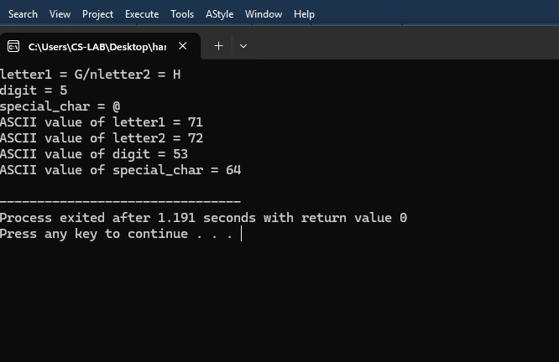

2. Write a C program to demonstrate float datatype2. Write a C program to demonstrate float datatype
2. Write a C program to demonstrate float datatype for BMI calculation
#include <stdio.h>
int main() {
float weight, height, bmi;
printf("Enter your weight in kilograms: ");
scanf("%f", &weight);
printf("Enter your height in meters: ");
scanf("%f", &height);
bmi = weight / (height * height);
printf("Your BMI is: %.2f\n", bmi);
return 0;
}
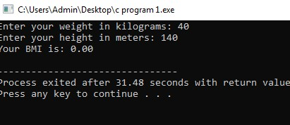
OUTPUT:

3. Write a C program to find the maximum of two numbers.
#include <stdio.h>
int main()
{
int num1, num2;
printf("Enter two numbers: ");
scanf("%d %d", &num1, &num2);
if (num1 > num2)
{
printf("The maximum number is: %d\n", num1);
}
else
{
printf("The maximum number is: %d\n", num2);
}
return 0;
}

OUTPUT :
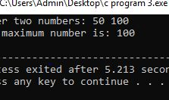

4.Write a C Program for voting eligibility check using Logical Operators.
#include <stdio.h>
int main()
{
int age;
char isCitizen;
printf("Enter your age: ");
scanf("%d", &age);
printf("Are you a citizen? (y/n): ");
scanf(" %c", &isCitizen);
if (age >= 18 && (isCitizen =='y' || isCitizen == 'Y')) {
printf("You are eligible to vote.\n");
}
else {
printf("You are not eligible to vote.\n");
}
return 0;
}
OUTPUT:
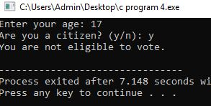
5. Write a C program to find the largest of three numbers.
#include <stdio.h>
int main()
{
int n1, n2, n3;
printf("Enter three numbers: ");
scanf("%d %d %d", &n1, &n2, &n3);
if (n1 >= n2 && n1 >= n3) {
printf("The largest number is: %d\n", n1);
} else if (n2 >= n1 && n2 >= n3) {
printf("The largest number is: %d\n", n1);
} else {
printf("The largest number is: %d\n", n3);
}
return 0;
}

OUTPUT:
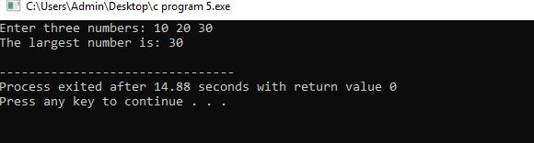
6. Write a C program that takes an integer as input and checks if it's a positive, negative, or
zero using if-else statements.
#include <stdio.h>
int main()
{
int num;
printf("Enter a number: ");
scanf("%d", &num);
if (num > 0) {
printf("The number is positive.\n");
}else if (num<0){
printf("The number is negative.\n");
}else {
printf("The number is zero.\n");
}
return 0;
}

OUTPUT:
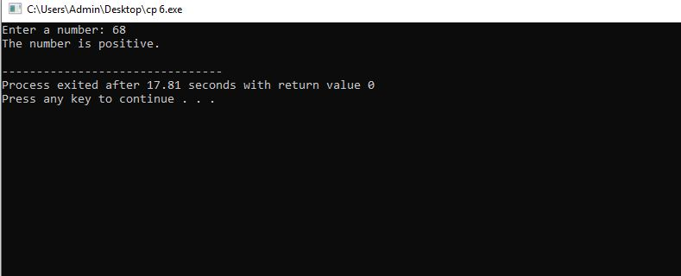

7. Create a C program that calculates the grade of a student based on their percentage score. Use if and else-if statements to assign grades (A, B, C, D, or F) according to the following criteria: A: 90% or above B: 80-89% C: 70-79% D: 60-69% F: Below 60%
#include <stdio.h>
int main() {
float percentage;
printf("Enter the student's percentage score: ");
scanf("%f", &percentage);
if (percentage >= 90) {
printf("Grade: A\n");
} else if (percentage >= 80) {
printf("Grade: B\n");
} else if (percentage >= 70) {
printf("Grade: C\n");
} else if (percentage >= 60) {
printf("Grade: D\n");
}else{
printf("Grade: F\n");
}
return 0;
}
OUTPUT:
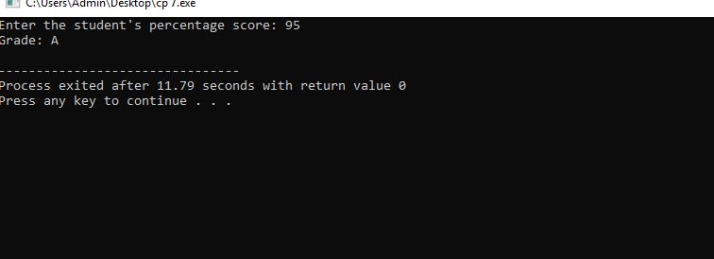

8. National Highway Department announces a scheme for the four wheeler in toll gate for 50 th year celebration. If the vehicle number is divisible by both 7 and 3 that will move on for free of cost. If the vehicle number id divisible by 2 and 8 then they should be pay half of the fee. Otherwise, you have to pay. Make sure the vehicle number doesn’t exceed 4 numbers

#include <stdio.h>
int main() {
int vehicleNumber;
printf("Enter the vehicle number (up to 4 digits): ");
scanf("%d", &vehicleNumber);
if (vehicleNumber < 1000 || vehicleNumber > 9999) {
printf("Invalid vehicle number. Please enter a number between 1000 and 9999.\n");
return 1;
}
if (vehicleNumber % 7 == 0 && vehicleNumber % 3 == 0) {
printf("Free of cost\n");
}
else if (vehicleNumber % 2 == 0 && vehicleNumber % 8 == 0) {
printf("Pay half of the fee\n");
}
else {
printf("Pay full fee\n");
}
return 0;
}
OUTPUT:

